Table of contents:
- The problem
- Component breakdown:
- Project management and version control.
- Two methods of project management for planning:
- Version control to show the work saved as I built my outcome:
- Phases of development and Phase Reflections:
- MY wireframe mock-up (20/7/26):
- MVP Plan (21/07/26):
- Other Planning :
- Advanced techniques
- Relevant Implications
MY PROJECT DEPLOYED ON A GITHUB PAGES SITE: https://oscarb123123.github.io/Standard-2/

PROJECT DESCRIPTION - AS 91893 Digital Media Outcome
Level 2 Digital Media · Student Documentation Template (Any project)
Use for any digital media outcome (web page/app UI, interactive media, etc.). Hub options include inventory tracker, finance learning tool, job board, or your own brief.
Student name | Oscar Berryman
Class / year | Year 12
Project title | Investment Decision Journal
Media type / stack | HTML, CSS, and Java
Teacher brief approved? | ☐ Yes
Date started | ________________________________

The problem
Who are the end users?
- The end users are people who are interested in investing, and want a clear, easy way to track their thesis across different stocks and investments.
What problem does the digital media outcome solve?
- The problem that the digital media outcome solves is the issue of people forgetting to review their theses on stocks as the market changes, this can lead to people not understanding what they hold, or becoming confused when their portfolio doesn’t represent their intentions.
Where is my interface made to be used?
- My interface will be made to be used on both large desktop screens and small mobile devices because I will build in responsive elements that make the interface able to be displayed on these.
What are my relevant implications?
- Accessibility – users of my system all have different accessibility needs
- Privacy / IP / Ethics – investment and financial decisions could be sensitive information
- Aesthetics / functionality – Users need to quickly understand investment information
- Functionality – Users need to have the ability to edit theses.

Component breakdown:
- This is what I initially wrote, early on in my development process.
What should users see/do when it works (What am I building)?
An app where:
- Users can add their current holdings, and enter and update their thesis for stocks.
- They can add their bear and bull case.
- They can add their confidence level.
- They can add their predictions for future price levels and business data.
- Users set a date for review on their thesis that triggers a notification to help them stay consistent in their views.
- They can write a reflection / update holdings when the alert triggers, which can help them learn how to analyse better In the future.
- Review feature could also function as getting users to review their watchlist holdings, to see if the right time to buy for them has come yet.
- Clean portfolio dashboard with sector exposure by percentage
- The interface should track average confidence level
Required component breakdown:
- Interesting animation for the background
- Ability to input stock holdings by value and share size
- A wide variety of stocks to choose from
- Ability to input users own thesis, and record it
- Ability to send users notifications and set review dates for their thesis

I then organized these requirements into the main components of my outcome the thesis system, thesis review system, dashboard system, accessibility, aesthetics and data persistence.
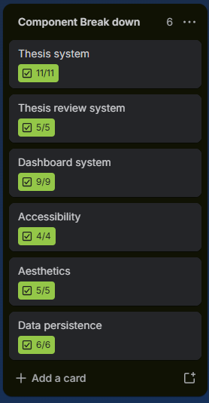
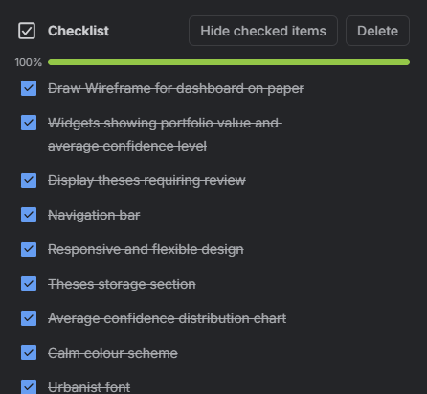
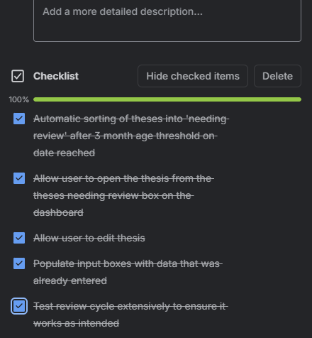
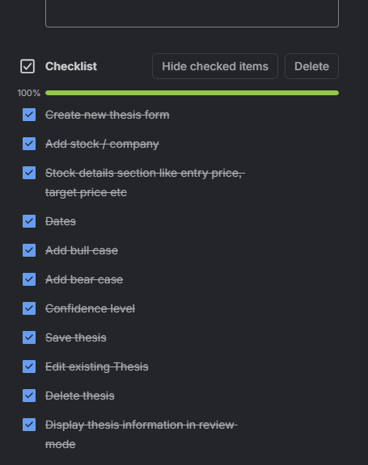
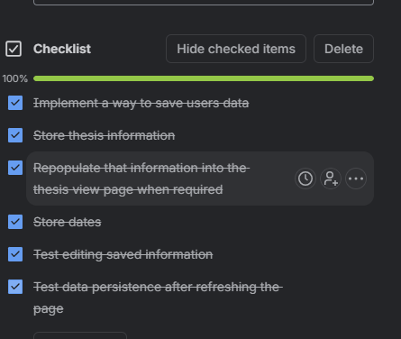

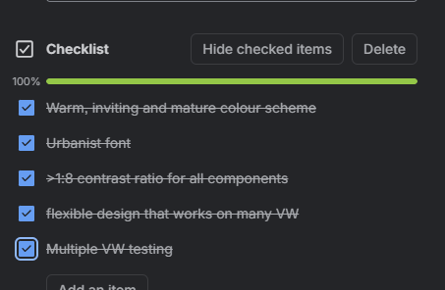
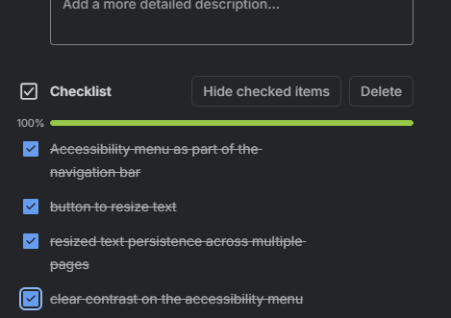

My worklog document shows me progressing through these tasks, although not explicitly because it’s too long to separate out into individual components, and it matches my development process more in the format it is now. My various testing tables show the testing processes for all of these components

Project management and version control.
I used Trello to write up the various different tasks I had to do for each phase. And then at the end of those phases, I did a reflection, reviewing the tasks an completed and what I didn’t get to. If these objectives were incomplete within their planned phase, I moved them to the next one or removed them if they would be too time consuming to complete.
I also maintained a detailed, dated worklog throughout my development as a way to show my development and debug process as I completed, rather than ticking off individual things on my Trello as I went. My testing tables also have dated records of testing, problems found, changes made (with links back to worklog for debug if necessary), and retests. Github shows my VS code commit history.

Two methods of project management for planning:
- https://www.figma.com/make/DsBcsbG96y2TW2J4hgVnID/Stock-research-app?t=hVCeLNTpkXmkmuug-1
- TRELLO link: https://trello.com/invite/b/6a69c69c2dd4bd84f5fd4544/ATTI13db58cdf2fba61c63cacbfaae6457733D2DD156/comp-sci
- I also used Netlify Stakeholder flashcards · AS91893 · AS91897 for both standards to ensure that I was hitting all of the relevant criteria, and ticked off the things I had done as I went.
- And my github link: OSCARB123123/Standard-2
This first image is a picture of my Figma project, which I used to get an initial idea of what I wanted my interface to look like, however its now deleted. So is the second image.

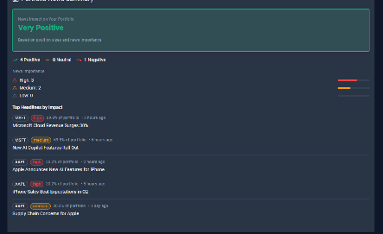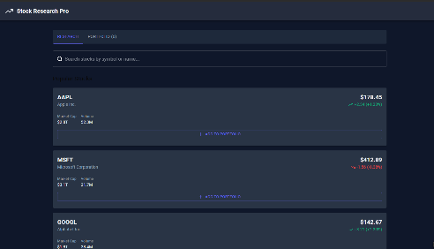
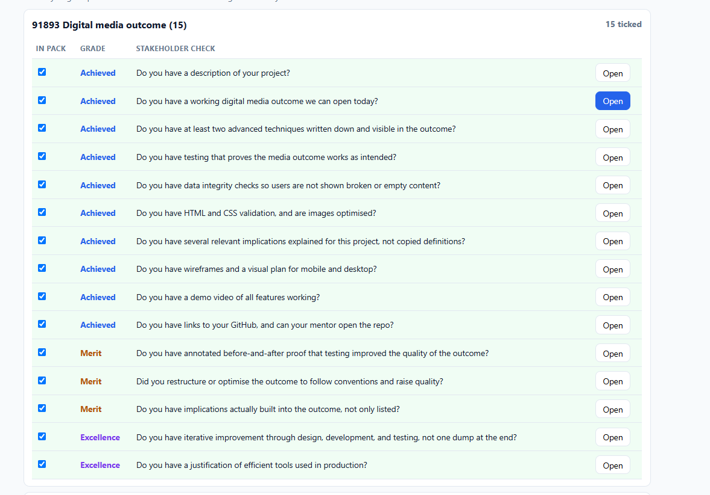
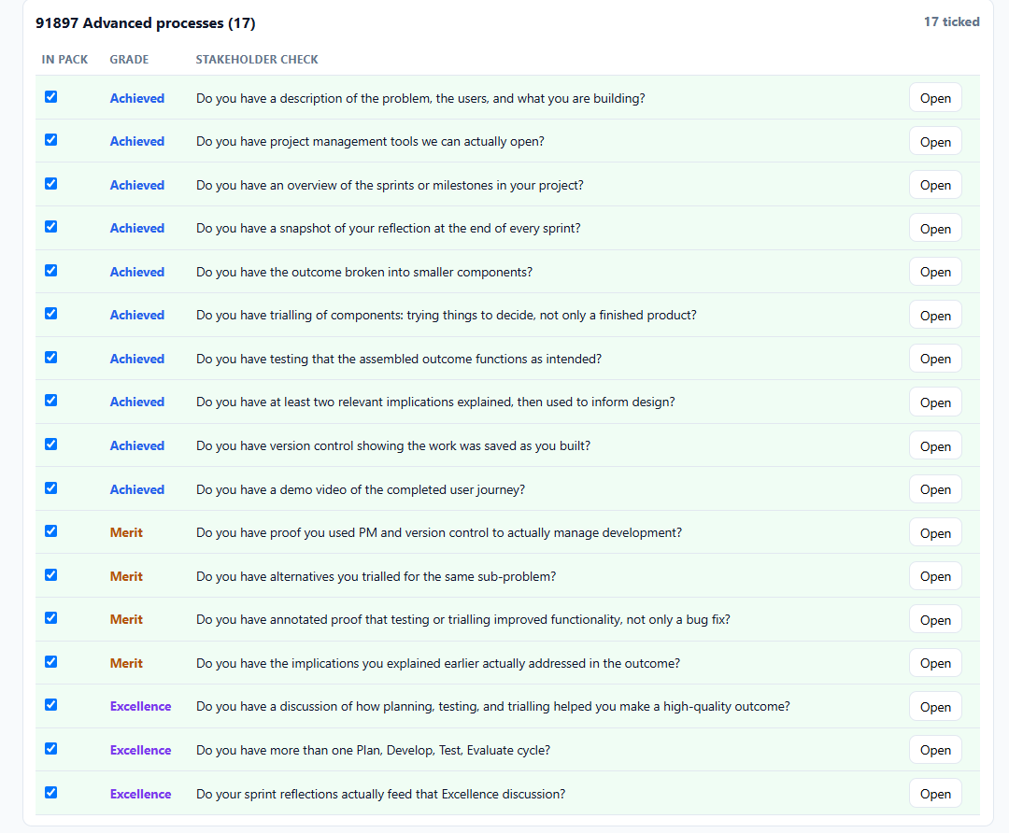

20/7/26: this is an image of how my trello board initially started out, I was using it for a to do list with the different netlify objectives in the to do collum, I then had a doing and a done collum to sort these cards as I compelted them.
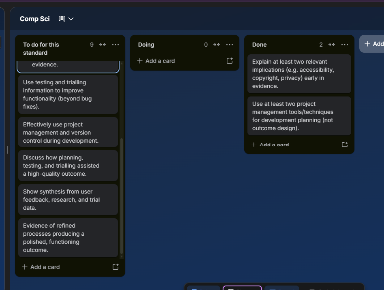

Below is an image of my trello board much later on. I have the different phases as separate boxes on the trello board, with them filled with the various objectives I need to do. I also have my component breakdown with smaller checklists inside each card at the end to keep me focused on building the features that I need to:
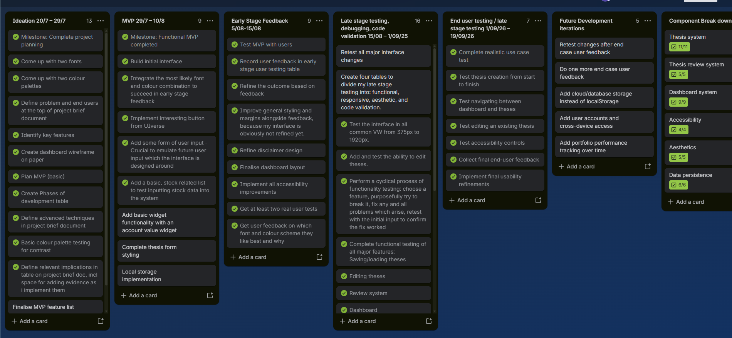

Version control to show the work saved as I built my outcome:
- GITHUB repository: OSCARB123123/Standard-2 which helps me to track version history
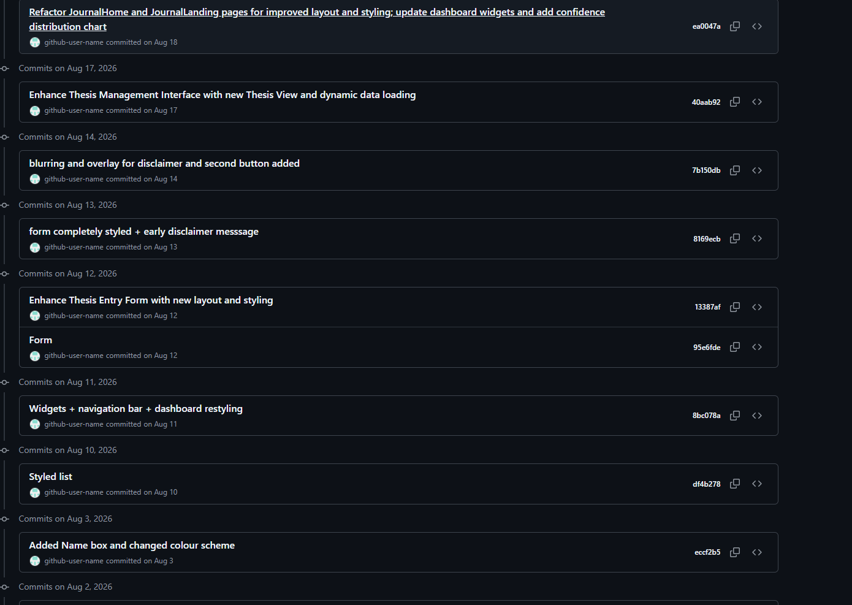
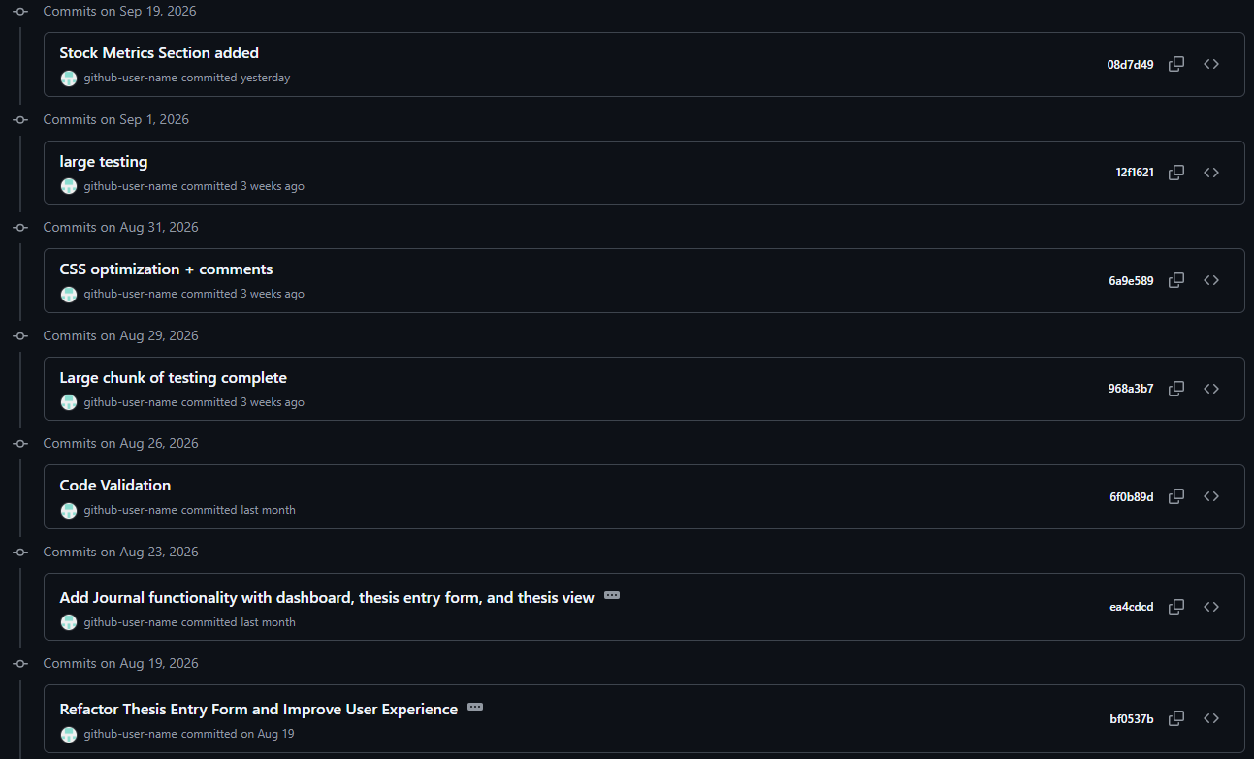

The two commits on July the 1st, contain an AI generated animation of brain neurons. I was going to do this at the start of my project and was going to include the prompts used to make it in my documentation, but it didn’t end up making it into my final outcome. My commit history shows this early experimentation as part of my development process
In a way this was part of my trailing.

Phases of development and Phase Reflections:
Date | Phase name | Where You can find Evidence | Goal | What was done
20/7 – 29/7 | Ideation | Top of my Project brief document | Establish the purpose, users, and the main important features of the Investment decision journal | Identified the problem of users not regularly reviewing their investment theses. I planned the layout I wanted the dashboard to have through wire frames. I came up with two font designs and two color palette designs, that I could use in my MVP. I also defined the key features to be things like average confidence level, a thesis needing review section  And a few other examples from my brief:  Users can add their current holdings, and enter and update their thesis for stocks.  They can add their bear and bull case.  They can add their confidence level.
29/7 | IDEATION PHASE REFLECTION | 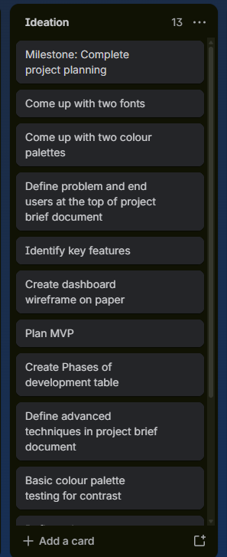 | 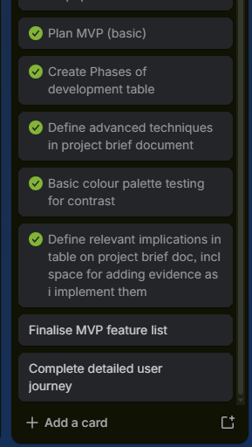 | What did I complete:  In the ideation phase I completed a comprehensive plan of my interface. I planned two fonts: urbanist and sensation, two color palettes a pink and a white one, I defined my problem, end users, and key features. I drew a wireframe on paper. I created a basic MVP plan, and the phases of development table. I defined my advanced techniques and relevant implications. And I also did some basic color palette contrast checking.  What changed or didn’t get completed:  I didn’t get to finalise the MVP feature list. I was mainly building it as I went, trying to make it as good as possible within the time restriction of this sprint. I also didn’t complete a detailed user journey, which I should have done because it is important for planning how the user will interact with my interface.  What did I learn / find:  I learnt that I like the combination of urbanist and the white color palette best, due to its high contrast ratio and mature appearance.  What I will do next:  I will build the MVP based on my initial plan, while continuing to refine the features and interface as I develop it.
29/7 – 10/8 | MVP | Worklog between 29/7 – 10/8 shows the development process of my MVP version | Build a very basic version of my interface | 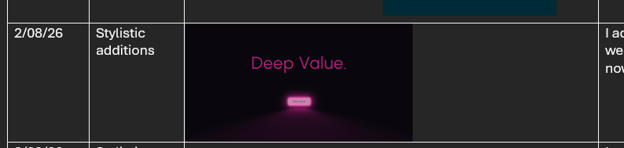  I built a minimum viable product version of my interface that contained the Beige-white-black color palette and the urbanist font because I deemed them to be most likely to be in my final outcome.  I did also have a pink one but I decided to change it. This MVP had core functionality like being able to add stocks and percentage change, but was extremely basic.
10/8 – 15/08 | MVP Reflection | 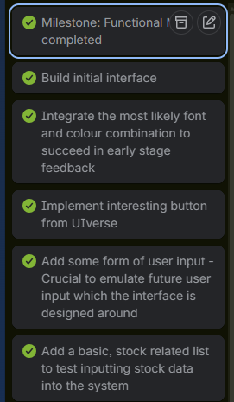 | 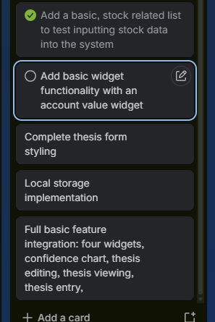 | What did I complete:  I built an initial interface, having a small version to show users for early stage testing. It had the most likely combination of fonts and colours that I picked, and it had a button element from Uiverse to make it look visually appealing. I added the ability to enter a name into the interface to emulate future user input, and had a basic stock related list to test putting stock data into the system.  What changed or didn’t get completed and when I actually did complete it:  I missed the objective of adding basic widget functionality, however I completed this a day after the phase was finished on the 11th of august, which is actually okay because my early user testing finished on the 15th. I didn’t complete thesis form styling, nor did I even have a thesis entry form by this stage. I also didn’t have local storage implemented yet, which is important because this is a key feature to my interface, so I really should’ve tested it during my MVP phase. Local storage feature was implanted on the 17th of august,  What I will do next:  I will take the basic MVP that I created and test it through two or more users in the early stage feedback.
5/08-15/08 | Early stage Feedback and trialing | Tests under  ‘Early stage Feedback’  Header in my testing table document  Visual and Aesthetics testing log shows evidence of refinement based on these tests. | Get real user feedback on my MVP and any additional development since | I got two users to test my interface – Kevin and Nikhil which tested my interface twice. I got these users to test the interface and then answer some questions relating to the aesthetics implication. I recorded their feedback and used it to identify areas for improvement. I then made changes based on their feedback and retested the interface to checker whether the changes had improved by outcome.  This feedback led to changes including adding the text resizer, improving text contrast, removing unnecessary navigation, and adding more useful dashboard content.
15/08 | Early Stage Feedback Relfection | 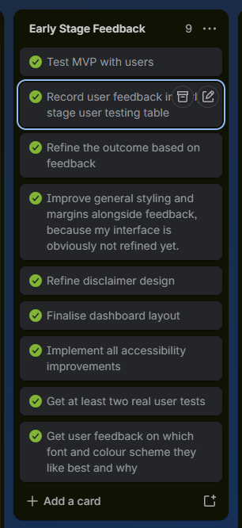 | 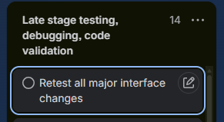 | What did I complete:  I did test the MVP version with multiple users, and collected their feedback in my early stage user testing table. I edited the interface based on this feedback in the visual and aesthetics testing table. I refined the design of my disclaimer and comprehensively tested for contrast of various different texts and backgrounds. I added a text resizer based on Nikhils feedback, and I got both users feedback on which font and color they liked best, and both agreed with me.  What changed or what I didn’t complete:  I decided to move the retesting phase to last stage testing, debugging, code validation because it makes more sense to do this after I’ve done some more tests.  I already finalized my dashboard layout when I was creating my paper wireframe, so this was completed a while back  What I will do next:  I will move on to late stage testing, debugging, code validation keeping in mind that I need to revalidate all major changes made to the interface during the early stage feedback process.
15/08 – 1/09/26 | Late stage testing, debugging, code validation | ‘Main Functional Testing table’ ‘Testing of aesthetics and layout for optimizations and refinement log’  ‘code optimization + testing’  ‘multiple viewport width device testing’  All headings in the testing table document. | Identify and fix all possible function, responsive, accessibility, aesthetic and code issues before the outcome has been completed, including retests to ensure fixes work. | I conducted late-stage functional, responsive, aesthetic and code validation testing to see if there were any remaining problems in my outcome after I had added new features, and after producing the MVP. I tested with multiple viewport widths, normal, invalid, and boundary inputs, and used formal HTML CSS validation procedures to efficiently identify technical issues.  I also tested the interface aesthetically based on the earlier stage feedback, and repeatedly tested things like contrast and margins to ensure a consistent design. I also optimised my code by removing unnecessary repetition, reusing CSS properties and correcting invalid or unnecessary code.
19/09/26 | Late Stage testing Reflection | 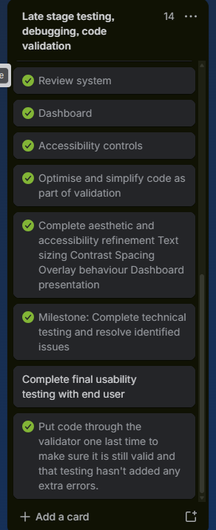 | 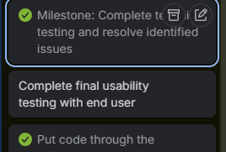 | What did I complete:  I created my four testing tables to divide my last stage testing into multiple sub stages. I did this as I went, and it wasn’t until right at the end that I actually separated them out neatly into headings with a contents page at the top of my testing table, however I still did this during my late stage testing phase. I tested the interface on all different VW sizes, and particularly in my functional testing table I performed the cyclical process of test, fix and retest. I also tested all of my main functional features extensively, user input in the form, saving, editing, etc. I also tested that the review system worked as I wanted it to and that the accessibility option saved correctly.  What changed or what I didn’t complete:  I decided to put all the code back through the validator again right at the end of my process to ensure my fixes stayed. I would’ve liked to get a little bit more late stage feedback (this is separate from end user testing), which would’ve helped me test and identify a few more problems regarding functionality and aesthetics.  I also planned to complete the end user testing within this phase but I didn’t, hence I created a new phase specifically for end user testing to complete this.  What I will do next:  Move on to the end user testing.
1/09/26 – 19/09/26 | End user testing / late stage feedback, | ‘Late stage feedback’  ‘Real Case User Testing’  Headings in the testing table | Get feedback from users in realistic conditions and use their feedback to identify and improve and remaining issues before the outcome is complete | Got a couple of late stage feedback tests from Nikhil around accessibility, layout and appearance.  One real use case test under realistic conditions, to help me understand if my interface is actually easy for users to navigate.  Lloyd who is an investor in the Australian and New Zealand stock exchange tested my interface completely with little to no instruction on what to do.
20/09/26 | End User testing Reflection | 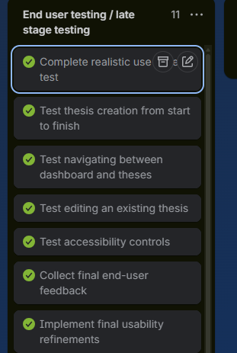 | 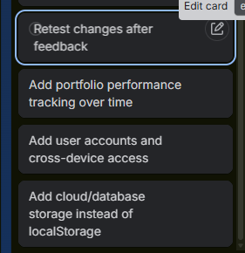 | What did I complete:  I completed one realistic test case where I gave a user who matched my intended audience a bit of context and a problem to solve with my system, and got them to do it without telling them how. He tested thesis creation from start to finish, navigating between dashboard and theses, editing and existing thesis, the accessibility controls.  I collected his feedback with a few questions and then used it to make a few final refinements to my interface, logging these in a small table right at the end of my testing table document.  What changed or what I didn’t complete:  One of my objectives in the Trello for this phase was to go back and retest the changes made after his feedback, which I haven’t got to do.  I also wanted to add portfolio tracking over time, and user accounts and cross-device access but I didn’t have time to add these.  I also think I would’ve liked to have more than one end case user test my interface, one isn’t really conclusive and is bound to miss some of the actual issues with my interface.  One final change I would’ve wanted to make was adding cloud / database storage rather than local storage as it is a bit risky storing sensitive financial data on users browsers in my opinion and isn’t really aligned with the privacy implication

MY wireframe mock-up (20/7/26):

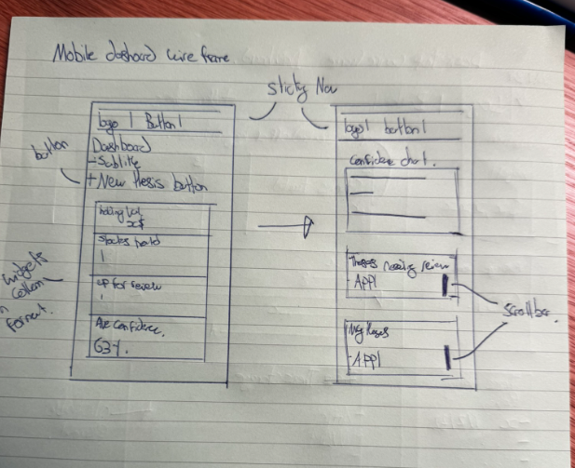
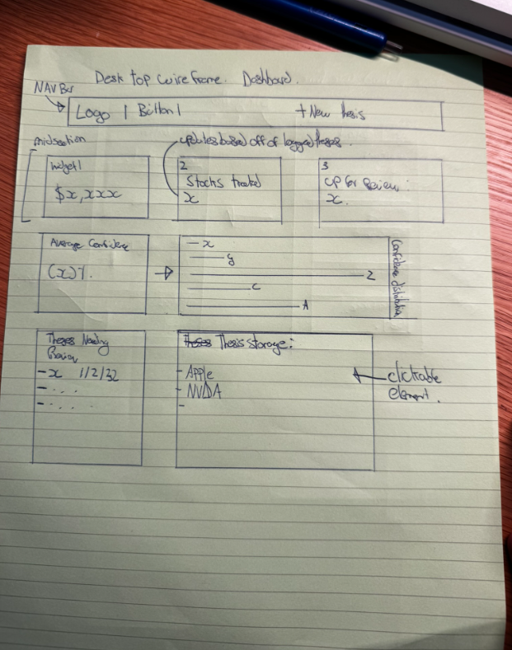

MVP Plan (21/07/26):
- I need my MVP (minimum viable product) to provide some sort of user interaction so that I can emulate more complex user input later on, which my interface is essentially based around
- I will do this through a name entry box
- I also want to add the most probable colour palette and font combinations, to give testers in the early stage user testing phase a visual representation of what I think would look best.
- I will also ensure to provide these testers with the other font (sensation) and the pink colour palette, as ask them to tell me if they think those two would be a better fit on the MVP
- MVP should have a basic list element containing stocks and percentage change, so I can practice inputting data into the system
- Should have basic data storage abilities because this is a crucial part of my interface.

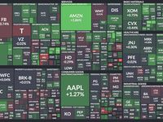
Other Planning :
Homepage that looks something like this
Review Urgency Heatmap
Tile size = portfolio weighting
Color = days until next review
- Green = recently reviewed
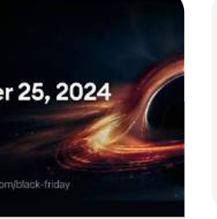
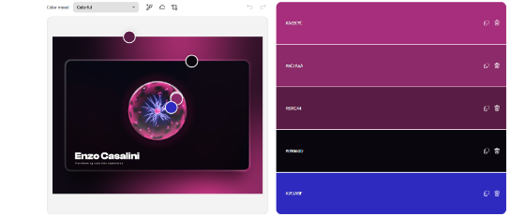
- Yellow = review due soon
- Red = overdue review
Color Palette Generator From Image | Adobe Express​
Enzo Casalini - Creative Developer Portfolio
Create a Palette - Coolors

Advanced techniques
Example advanced technique | What it might look like | Where in my project
CSS custom properties / themes | :root tokens for colour, space, type | :root {  --brown: #7B5132;  --apricot: #D98452;  --beige: #FFC67E;  --off-white: #FFEEC7;  }  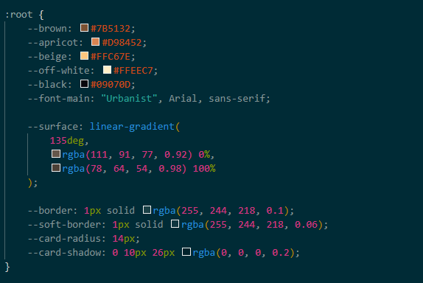  I use CSS custom properties in the :root selector to define reusable colours and other design values. These variables are used throughout the interface to maintain a consistent visual style and make the design easier to modify.  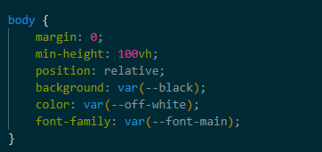  This is visualized in a very consistent color scheme appearance throughout my site, as the root variables mean each shade of color Is exactly the same.  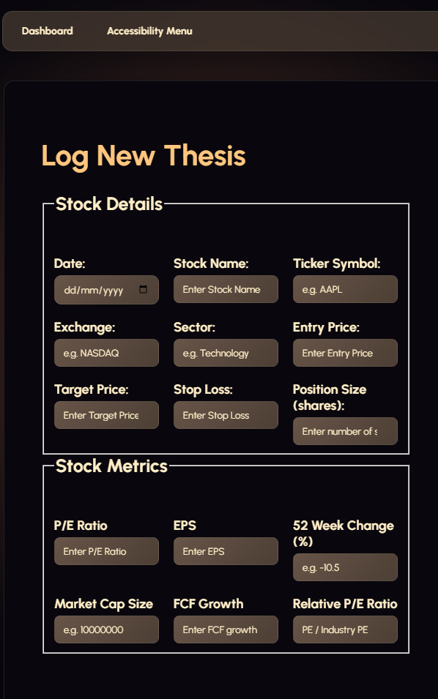  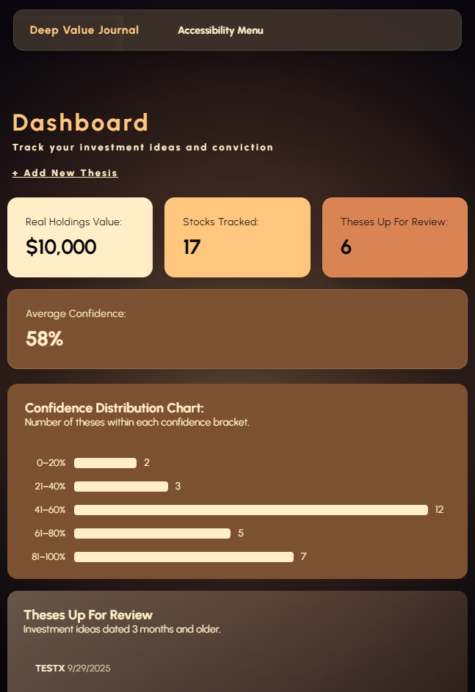
Responsive layout system | Mobile-first flex/grid + breakpoints  Flex elements used for CSS properties  Media queries used | I use Flexbox/Grid and media queries to create a responsive interface that adapts to different screen sizes. This allows the dashboard, navigation and content cards to rearrange appropriately on mobile and larger screens, making the outcome usable across different devices.  Within dashboard-home flexbox is being used to control how the elements inside the dashboard are laid out vertically. Display: flex; turns dashboard-home into a flex container, and its children become flex items, allowing flexbox to control their positioning and sizing.  Flex-direction: column means that my dashboard sections stack in a column rather than a row like flex box does as default.  Align-items: stretch; controls how the flex items are positioned across the cross axis, and it means they expand to fill the available space.  Image shows the code in my dashboard-home section:  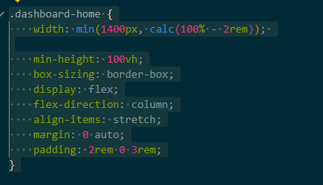  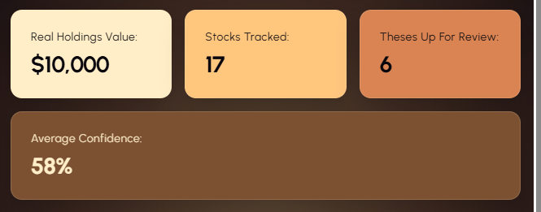  Image shows the child elements within my dashboard container expanding to fill the available width:
Reusable UI pattern | Shared card/component classes or partials
Data-driven content | Local storage used rather than JSON to store user data | Local storage has been used to save the different parts of users theses.  Local storage has been used to store the thesis entries with  localStorage.setItem(  "theses",  JSON.stringify(theses)  );  JSON.stringify() converts the javascript array of thesis objects into a JSON string before saving it  I also use local storage to retrieve saved data, and save new data of course.    Picture of the theses in stored theses:  Json and localstorage to save users thesis parts. The data will be accessible in the users ‘saved theses’ box on the home page of the dashboard.  When clicked on in the saved theses section, saved thesis data populates a form showing all the information that was entered previously, organized neatly.  Image of saving function:  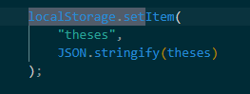  Image of retrieval function code.  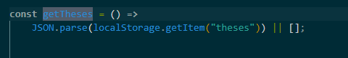
Scripts / interactivity | Custom JS for filters, tabs, states
Third-party library | Charts, icons, UI kit used with understanding
Asset pipeline / optimisation | Compressed images, sprites, consistent paths

My ≥2 techniques for assessment:
- I am going to use a JSON file to track users investment thesis and options. I have chosen this because it allows me to record a lot of data, for different users and populate more than one html file with this data. I also like how easy it is to save things to it from my previous assessment.
- Responsive system layout using flexbox / grid to ensure my interface can be used on mobile devices and larger screens. This makes it more accessible to a greater amount of users, and especially casual investors which is most people.

Relevant Implications

Implication | Why it matters for my user | How I addressed (how it informed my design) | Evidence
Accessibility | Because my app is designed for all investors it’s important that people with disabilities can use it. Most users will have different visual and other accessibility needs, ensuring the interface provides options that makes its content easier to read and interact with.  feedback suggesting a text resizer from Nikhil:  This means the relevant implication of accessibility was thought about early on in my development, during the early stage testing phase. | I addressed this implication through extensive high contrast testing, and the use of global variables to ensure all my colours were the same.  Specifically in my widgets on the dashboard, I made sure to test that they were high contrast before implementing the colour combination into my final design. This shows the implication of accessibility as it makes text, buttons, icons, and other interface elements easier to distinguish from their background. This makes text easier to read, helping users with visual impairments, and reduces visual ambiguity so users don’t have to rely on subtle colour differences to understand the interface.  I also added appropriate headings to make the interface easier to use with screen readers. Using headers like <h1> <h2> creates a hierarchy. Screen readers use headings as navigation landmarks, allowing users to jump around the screen by headings rather than listening to every piece of text.  I also added a text resizer as specified by Nikhil in his feedback. This addresses the accessibility implication because it directly responds to different users having different visual / accessibility needs.  See implementation log for my text resizer and accessibility menu in my work log on the 26th of august. | Picture showing a contrast ratio of 12:1 for one of my widgets on my dashboard  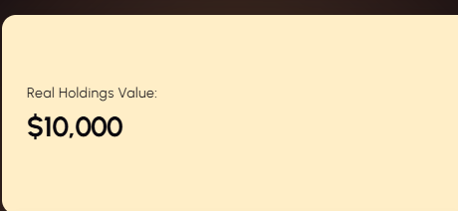  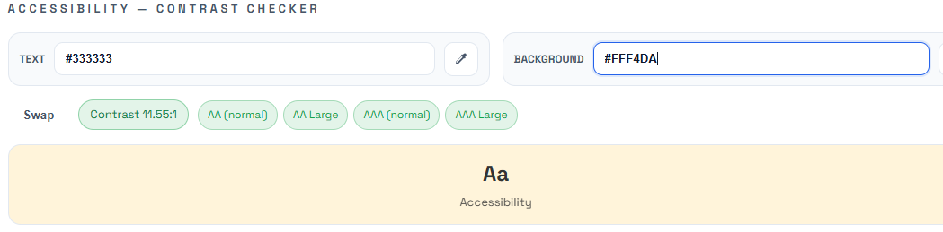  This one shows a contrast ratio of 13:1 for the stocks tracked element on my dashboard  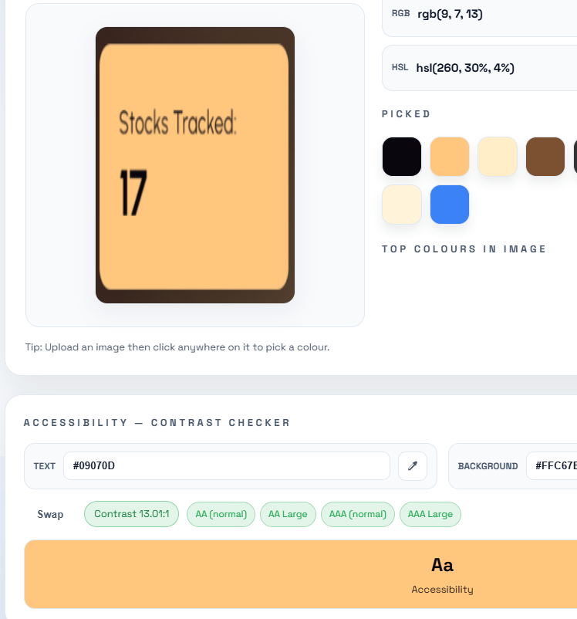  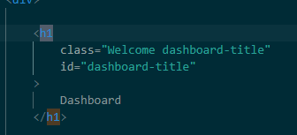  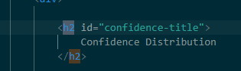  Here are images of my using an h1 heading for my dashboard title, and an h2 heading for my confidence distribution chart title, which creates the hierarchy of the dashboard title as my main page/topic and the confidence distribution chart as a major section.  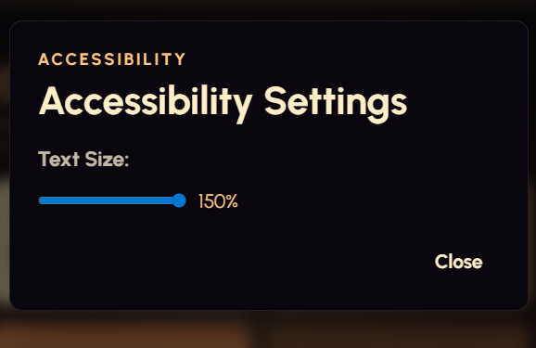  Image of my text resizer  Text on my dashboard sized up to 150% of its original:  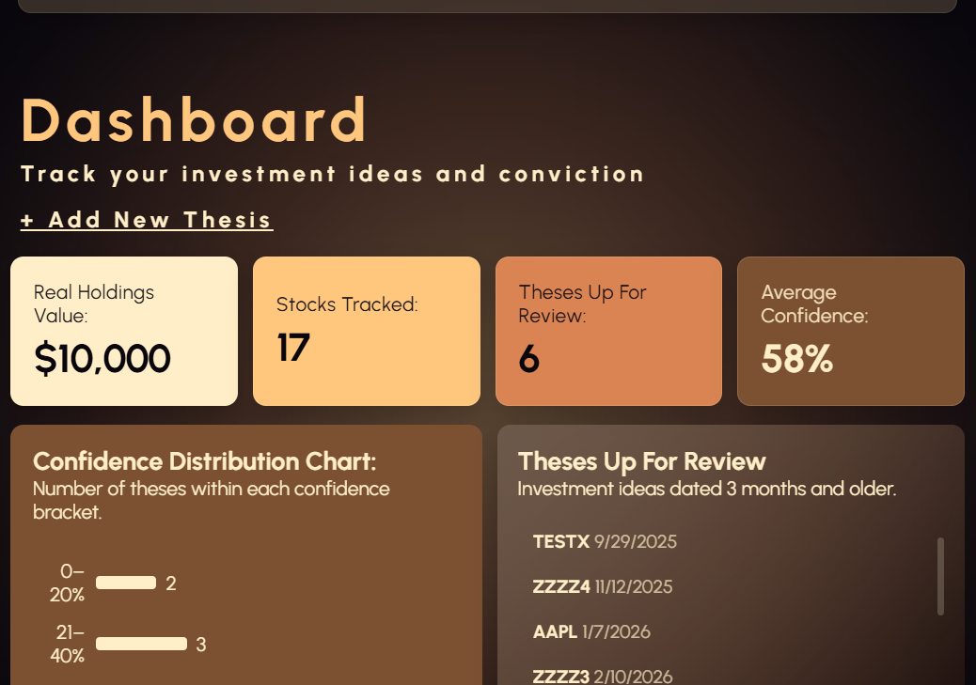
Privacy / ethics | Because my application stores users’ investment decisions, including information about trades and financial data, it is important that their privacy is managed in a way reduces potential privacy risks. | I addressed this by displaying my disclaimer on top of the thesisentryform.html with a blurred background around it which requires users to acknowledge the disclaimer before continuing. It explains that their data will be stored locally if they choose to continue.  I also provide information about how their data is collected and warn users not to enter personal information they do not wish to share, as this may be visible to other users with access to the same device.  This shows the privacy implication as my interface actually addresses the privacy risk identified by giving users information about what happens to their data, allowing them to make an informed decision about it before entering. | 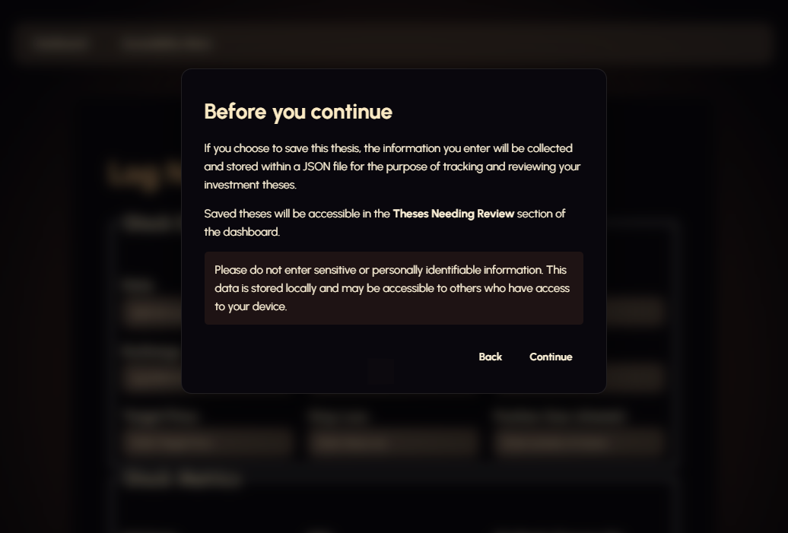  Image showing the disclaimer I implemented that automatically triggers when opening the thesis entry form page
Aesthetics / functionality | My users need to be able to make quick, informed investment decisions. It also needs to be easy to understand that information, so the visual design and functionality of the interface need to be designed in a way that makes that information easy to access. Poor layout or an inconsistent design could make my interface difficult to use. | I used css flexbox throughout many aspects of my interface to arrange related information and controls in an organized layout. This makes the interface easier to navigate and allows user to quickly locate related investment information.  I also used media queries to adapt the interface to different sizes, ensuring users can interact with the applications features on a wide variety of devices. And ensures that the organizes layout is maintained across multiple sized screens.  One specific example of media queries is the grid on the stock details section. On a mobile phone sized device the grid goes down to two details per row, but on larger desktop screens it goes up to three. This ensures the content on the screen remains visible on many screen sizes.  Together these shows the implication of aesthetics and functionality because they ensure my interface is always easy to navigate, clear, and that the information on it is presented in an easy to understand way, supporting the needs of the user identified in my purpose. | 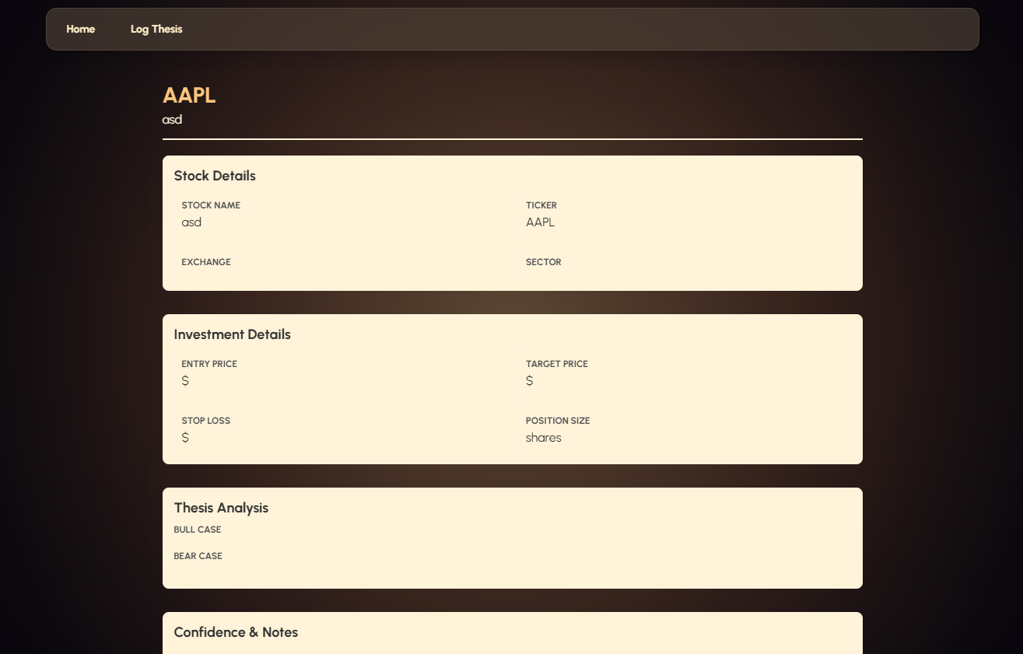  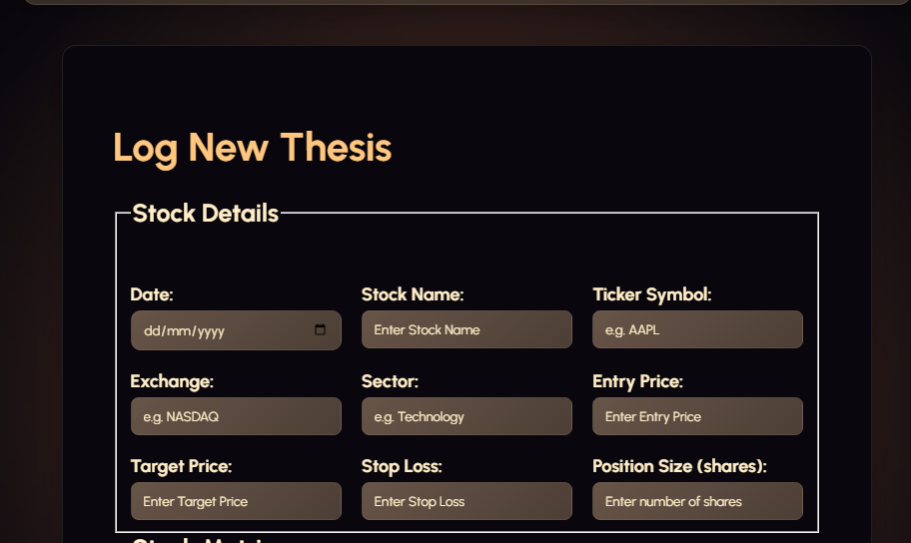  This image shows the grid layout on a large desktop screen as media queries sets it out to be:  While this image shows the grid layout which changes to be two per row on a smaller sized device:  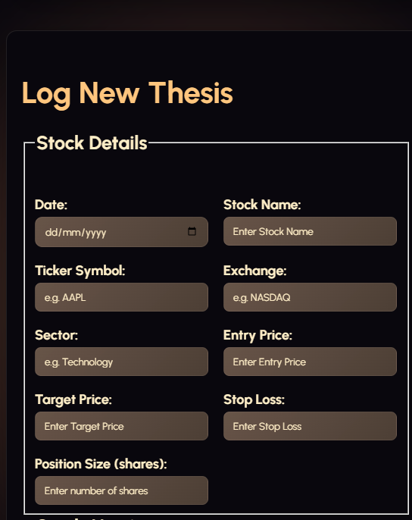  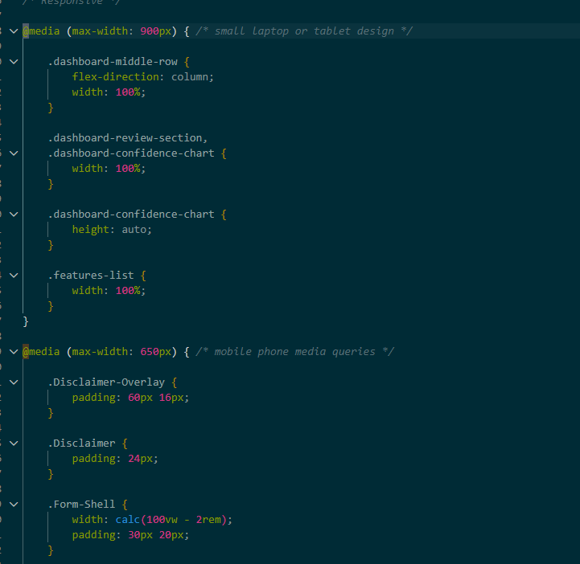  Here’s an image of some of the media queries code used in my interface.  Below shows an image of my dashboard. I used display: flex; property for the container that all these elements are in to change how they are laid out. Flex box naturally arranges them along a row rather than stacking vertically as in a row.  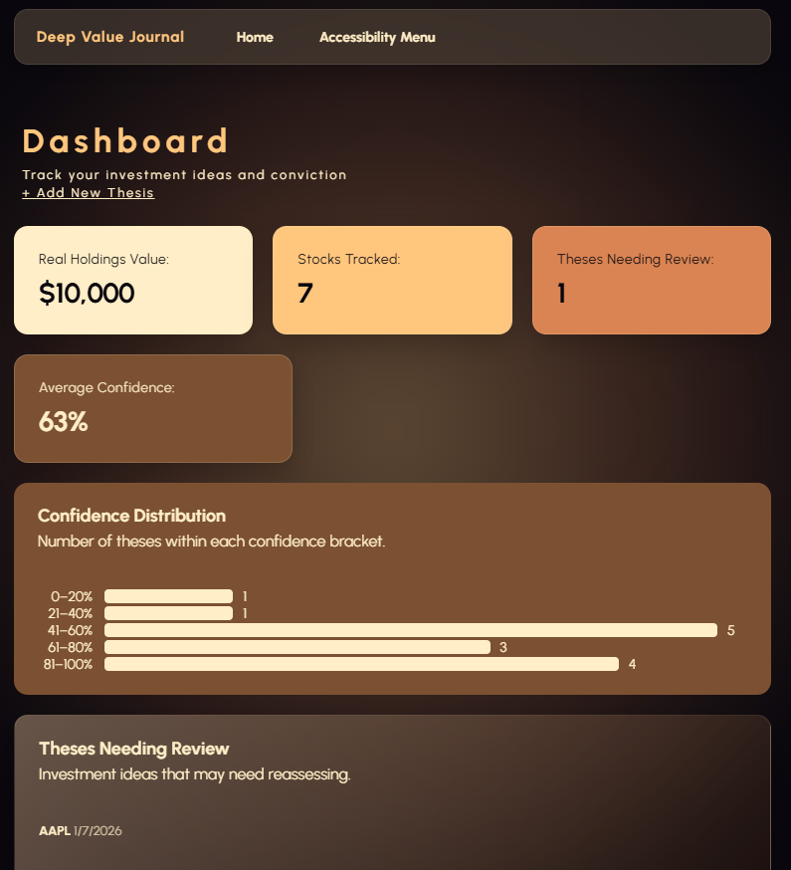
Intellectual Property | The intellectual property implication matters for users because if I had used copyrighted assets without permission, I could have to remove or change parts of my journal which could affect the user experience, by removing functionality they were used to.

